Display Newsman Connector entities in the Sitemap

- Access Customization area in Microsoft Dynamics CRM:
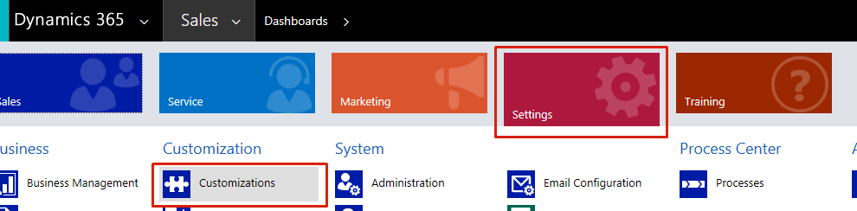
- Access the Default Solution option:
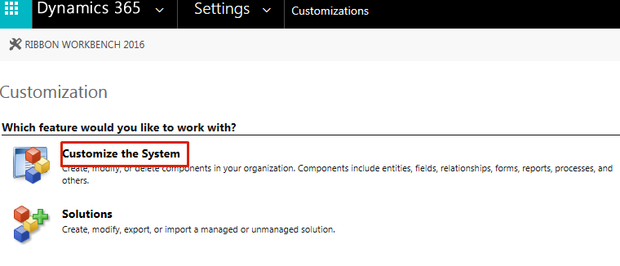
- In the newly opened window, search and select, in turn, each of the Newsman Connector entities:
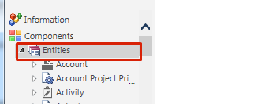
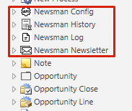
- Select one Newsman Connector entity:
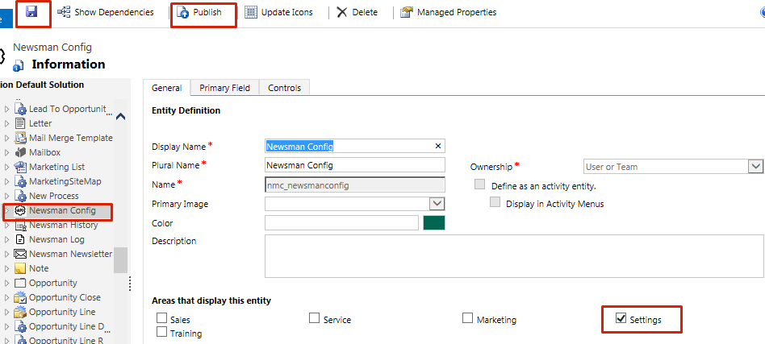
- After the screen on the right is showing the entity information, check the Settings area, for example (you can check whichever area you want to be displayed in)
- Save
- Publish the customization.
Once the publishing finished, select the next entity and follow steps a) to d) for each entity.

